Objectives:
- UML Diagrams
  - Use Case Diagram
  - Activity Diagram
- Variables and data types
- Arithmetic Operators
- Parse() and ToString() methods

Problem Description: Design a C# Windows Form Application to display the entered data to the screen and to calculate the mean of the four semester GPAs.

GUI Design: Similar to Figure-1 –
NOTE: Provide the key access for each button so that the user can press Alt + that letter to click on the button. Ex: To make S the key access for the button Summary, use &Summary for its Text property.

Summary Button:
When clicked display the student’s full name, GPAs and selected college as shown in Figure 02.
Pseudo-code:

- Declare four variables for semester GPAs (data type double).
- Declare other variables as needed.
- Store the entered GPAs in the corresponding variables, use the Parse() method.
- Display the student’s full name to the output box.
- Display the GPAs with 2 digits after the decimal point.
- Display the college as shown in Figure-2

Average Button:
When clicked it computes and displays the average GPA as shown in Figure 03.
Pseudo-code:
- Declare four variables to store GPAs (data type double).
- Declare a variable (data type double) to store the sum of the four GPAs (optional)
- Declare a variable to store the average of the four GPAs.
- Parse the entered GPAs in the corresponding variables, use the Parse() method.
- Compute the average (sum of 4 GPAs divided by 4) and store it in declared variable.
- Display the average with 2 digits after the decimal point as shown in both Figure-3 and Figure-4.

Clear Button:
When clicked should clear all the input and output boxes. Set the focus to the top Textbox.

Exit Button:
End the program execution.

Diagrams:
Note: Capture the diagrams by using the Snipping Tool and past the images on this document.
- Draw a Use Case Diagram illustrate the functionalities of this application.
- Draw an Activity Diagram to illustrate the steps in the click event of the Average button.

Deliverables:
- One document with the images of the Use case diagram and the activity diagram.
- Zipped folder of the finished project.

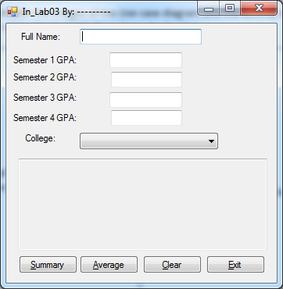  Figure-1 GUI Design | 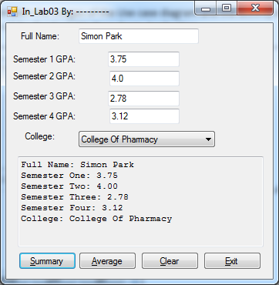  Figure 02. Output when Summary button is clicked.
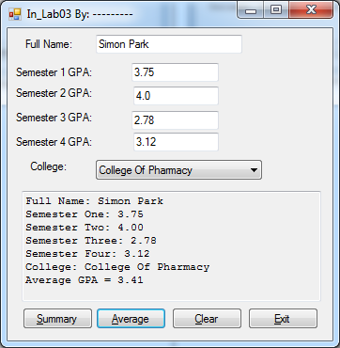  Figure-3 – Average button clicked after Summary button | 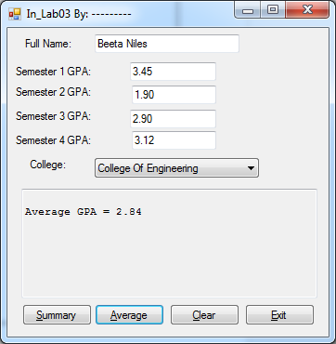  Figure-4 Average Button is clicked before Summary
